Quiz 6 (Week 6)
1. Which among the following statements are NOT TRUE?
(a) Embedded systems need not contain only hardware.
(b) A digital alarm clock with snooze functionality is an embedded system.
(c) For all embedded systems, the latency for computation of the result is not a problem as long as it is correct.
(d) For all embedded systems, the correctness of the result is not a problem as long as the latency is minimal.
(e) RAM and EEPROM are typically integrated on-chip in a microcontroller
(f) Very few microcontrollers are sold per year compared to general-purpose microprocessors
(g) A microcontroller has higher computing power than a typical microprocessor
(h) A microcontroller has a rich set of on-chip peripherals in comparison to microprocessor.
Ans: f, g
2.What brown out reset (BOR) circuit does by monitoring which of the following:
(a) Clock Frequency
(b) Temperature
(c) Supply Voltage
(d) Current Draw
Ans: C
3. Describe types of memory used in embedded systems and for what purpose?
SRAM: Static random-access memory is a type of random-access memory (RAM) that uses latching circuitry (flip-flop) to store each bit. SRAM is volatile memory; data is lost when power is removed. The term static differentiates SRAM from DRAM (dynamic random-access memory). SRAM will hold its data permanently in the presence of power, while data in DRAM decays in seconds and thus must be periodically refreshed. SRAM is faster than DRAM but it is more expensive in terms of silicon area and cost; it is typically used for the cache and internal registers of a CPU whil DRAM is used for a computer’s main memory.
DRAM: is a type of random-access semiconductor memory that stores each bit of data in a memory cell, usually consisting of a tiny capacitor and a transistor, both typically based on metal–oxide–semiconductor (MOS) technology. While most DRAM memory cell designs use a capacitor and transistor, some only use two transistors. In the designs where a capacitor is used, the capacitor can either be charged or discharged; these two states are taken to represent the two values of a bit, conventionally called 0 and 1. Data stored in this RAM needs to be refreshed every few milliseconds or else it will end up being erased, even if the power is being applied continuously the data still needs to be refreshed. This action is taken care of by a special device named DRAM controllers. The reason behind this dynamic behavior is because of the capacitor present in its design.
Masked ROM: The main characteristic of this device is the fact that the data is written onto the device as it gets manufactured and it is impossible to change them. This is done by designing the chip in such a manner so that it already contains the necessary data. They usually serve the function of storing the bootloaders in micro-controllers and to store microcode on microprocessors. This type of storage is generally used in mass-produced, long term devices where each penny counts.
PROM: PROM stands for Programmable Read-Only Memory. These are programmable chips, the main characteristic being it can only be programmed one time. That is it cannot be erased or reprogrammed. They are also known as One Time Programmable devices or OTPs for short. They are used to store the firmware and constants in the source code. These are used on devices that are still mass-produced but have a relatively shorter life as compared to the devices that use Masked ROMs.
EPROM: EPROM stands for Erasable Programmable Read-Only Memory. These chips usually have a small glass window on top and if you expose them to direct sunlight that will erase the chip’s data. They can then be programmed again with fresh data. Similar to PROM they are also used to store firmware and constants in the source code. But this kind of chip is usually used in the development phase of the software as erasing and reprogramming the chips is a vital part of the development cycle.
EEPROM: EEPROM stands for Electrically Erasable Programmable Read-Only Memory. These chips can be erased and reprogrammed using electricity as opposed to exposing them to UV rays as EPROMs. They can be used for storing firmware during the development phase of the product, storing runtime constants after production, storing updatable firmware after production.
Flash memory: It has all the qualities of EEPROMs except one. EEPROMs are re-programmable one bit at a time, while flash storage is a re-programmable one block at a time. The block size (X number of bytes) usually can be found on the given chip’s specifications. The main advantage of flash memory is that it is cost-effective (per byte) compared to EEPROMs and hence are used for storing large files.
NVRAM: This is a special type of RAM that can store data permanently. It’s basically an SRAM with a power supply. This type of storage on the PC world has a special name called “RAM disks”. The downside is that SRAM per byte is very expensive compared to any of the types mentioned above and hence not very cost-effective. This type of RAM is usually used in applications where startup time is extremely important, and we cannot afford to lose even microseconds of time trying to load a program from slower storages like flash or EEPROM.
4. The input Low-pass filter of a signal conditioner is made of 10k resistor and 100pF capacitor. At what frequency is the Vout error less than 0.1%?? Demonstrate by 2 ways.
First method: calculation
Capacitive reactance of a capacitor in an AC circuit is given as:
in Ohm’s
Current flow in an AC circuit is called impedance, symbol Z and for a series circuit consisting of a single resistor in series with a single capacitor, the circuit impedance is calculated as:

Then we can get the RC potential divider equation:

Based on the equation above, Vout / Vin = 0.999 = , Xc = 223439.0577
f = = = 7126.582 Hz
Ans: 7126.582 Hz
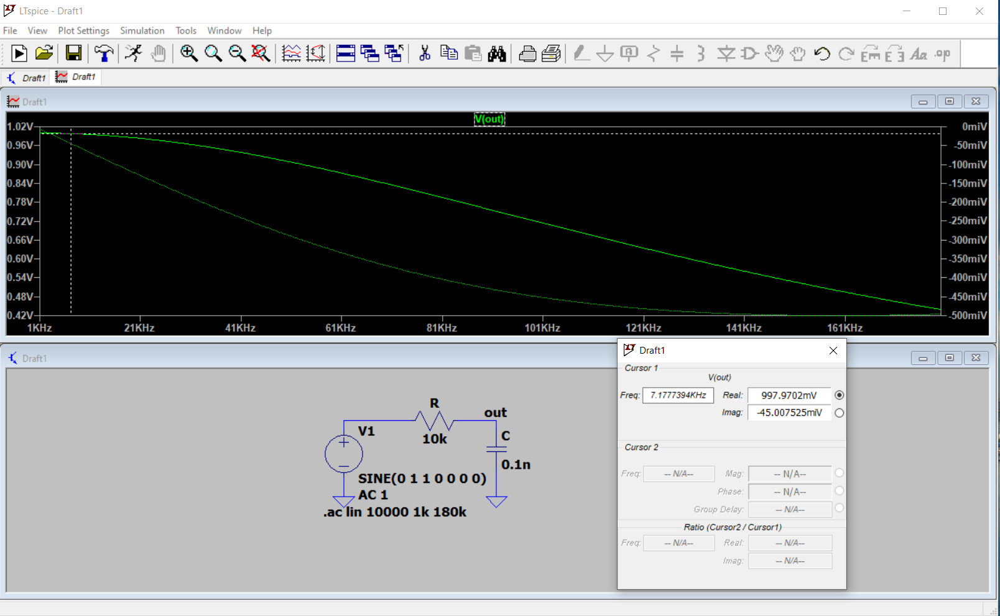
Second method: LTspice
We can see from the above plot that frequency about 7.2kHz has Vout approximately 0.999 percent of Vin, so it proves the calculation above.
To further improve the simulation result, I calculate the cut-off frequency as = 159,235.668 Hz, which is nearly the same as the simulation result
